EEC 521 Software Engineering

Employee Login Portal

USER MANUAL

Team Members

1. Sriniketh Venkatesh (2822307)
2. Harsha Ganesh Samudrala (2834550)
3. Shashank reddy Kunta (2812308)

# TABLE OF CONTENTS

TABLE OF CONTENTS 2

SYSTEM TECHNICAL OVERVIEW 4

EMPLOYEE LOGIN PORTAL PROFILE 4

SYSTEM SCREENSHOTS 5

LOGIN 5

DEVELOPER PAGE 6

LEAD PAGE……………………………………………………………………………………………………………7

LEAD PAGE CONTENTS……………………………………………………………………………………………..8

MANAGER PAGE……………………………………………………………………………………………………..9

MANAGER PAGE CONTENTS……………………………………………………………………………………...10

APPENDIX ……………………………………………………………………………………………………………11

**INTRODUCTION**

The Employee Login portal is a web application that is designed to manage the tasks that were assigned by the manager to the leads and developers.

The system automates the following would be complex activities;

* + 1. Employee Login
    2. Employees can view their own details
    3. Employees can see the tasks that were assigned to them
    4. Employees with the role of **Lead** can view the list of all the **developers**.
    5. Employees with the role of **Manager** can view the list of all the developers and leads
    6. Employees with the role of Manager can be able to assign tasks to all the leads and developers.

# SYSTEM TECHNICAL OVERVIEW

The **Employee Login Portal** is a web-based employee management system supported by the MySQL database which stores all of the application data highly secured and access is limited to authorized users. The application uses role-based login.

# Employee Login Portal Profile;

The Task Manager is a web-based employee management system. The implementation of this management system creates a centralized pool of data for all employees (Leads, Managers, Developers). This puts at easier what would be hard tasks, work which takes quite a long time takes seconds while using the software. Users are categorized into levels (Managers, Leads, Developers), and each level accessibility is limited to only activities of that level. For example, a manager only can assign tasks to leads and developers and only leads and managers can be able to see the list of developers. This kind of information sharing simplifies resource sharing among different departments of the company thus simplifying the decision-making process and the overall impact is effective employee management.

The system deploys modern security and encryption mechanisms to manage employee data for example username and password are encrypted before being transverse from one page to another, this limit intrudes who would hack user session

**SYSTEM SCREEN SHOOTS**

**LOGIN**

For the Employee Login Portal, since it is an employee role-based login, The employee will get the credentials automatically from the organization. For the 1st time, the employee has to login with these credentials. After that, the employee can change the password.

Password characteristics should be as follows:-

The password should include more than 12 characters

Password should contain alphabets, numbers, and special characters.

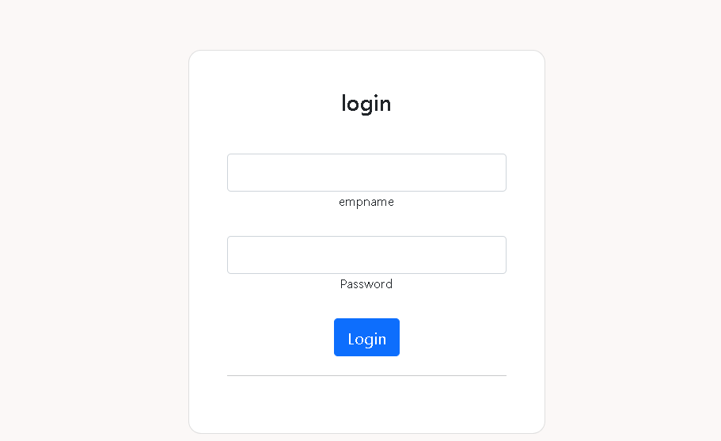

## **Figure1: Employee login Portal page**

**DEVELOPER PAGE**

In Employee Login Portal, the roles are divided into 3 levels. Level 50 stands for Developer. When a developer login with the credentials, the page has two tabs (employee details and assigned task) will be shown. The employee details tab consists of the developer employee Id and level. The assigned task tab consists of the list of all the tasks that were assigned by the respective manager. If there is any mistake in employee details, please contact the administrator to change the details.

**Figure: -2-Developer page**

The assigned task tab consists of the tasks that were assigned by the respective manager along with the task description. As a developer, if you need to make any changes in the task description, contact your respective manager to edit it.

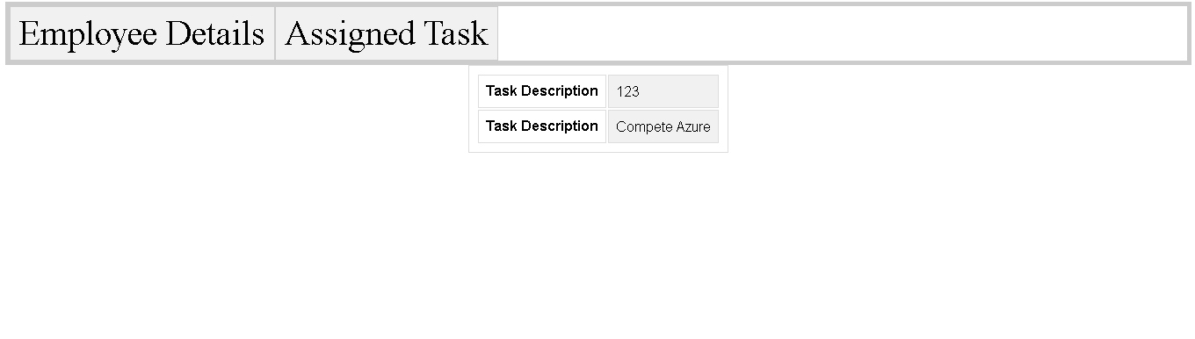

**Figure: -3-Assigned task tab**

**LEAD PAGE**

In the Employee Login Portal, the roles are divided into 3 levels. Level 51 stands for Lead. When a lead login with the credentials, the page has three tabs (employee details, assigned task, and developers list) will be shown. The employee details tab consists of the lead employee Id and level. The assigned task tab consists of the list of all the tasks that were assigned by the respective manager. The Developers tab consists of the list of all the developers in the company. If there is any mistake in employee details, please contact the administrator to change the details.

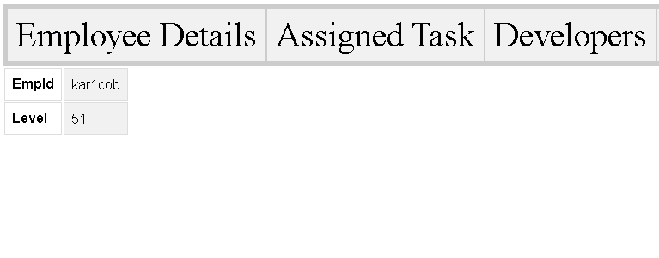

**Figure: -4- Lead page**

The assigned task tab consists of the tasks that were assigned by the respective manager along with the task description. As a developer, if you need to make any changes in the task description, contact your respective manager to edit it.

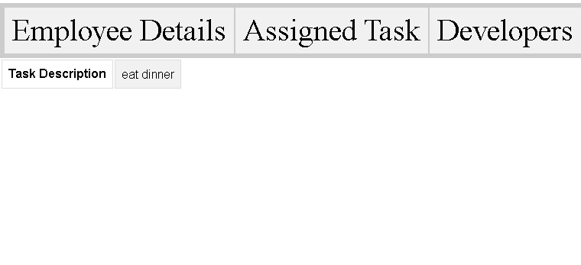

**Figure: -5- Assigned task page for lead**

The Developers tab consists of the list of all the developers who are there in the company. This list automatically updates the data in the database whenever there is a new developer joined in the company.

If someone is missing the list, Please contact the administrator.

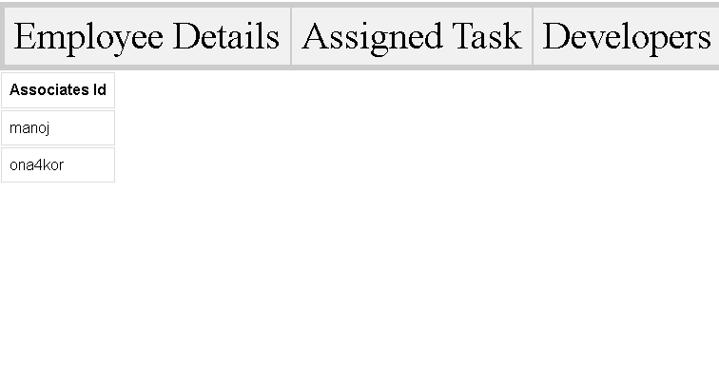

**Figure: -6- Developer list**

**MANAGER PAGE**

In Employee Login Portal, the roles are divided into 3 levels. Level 52 stands for Manager. When a lead login with the credentials, the page has three tabs (employee details, assign a task, developers list, and lead list) will be shown. The employee details tab consists of the lead employee Id and level. The assign task tab consists of the link to assign the tasks to the developers and leads. The Developers tab consists of the list of all the developers in the company. The leads tab consists of the list of all the leads in the company. If there is any mistake in employee details, please contact the administrator to change the details.

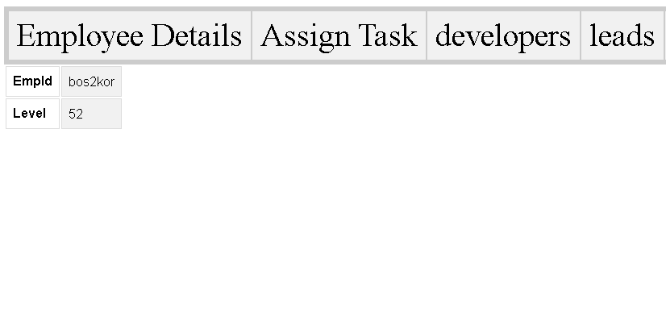

**Figure: -7- Manager page**

The assign task tab consists of the link to assign the tasks to the developers and leads. As a manager, you can assign tasks to leads and developers in the company. A manager can see the list of all the tasks that were assigned to them.

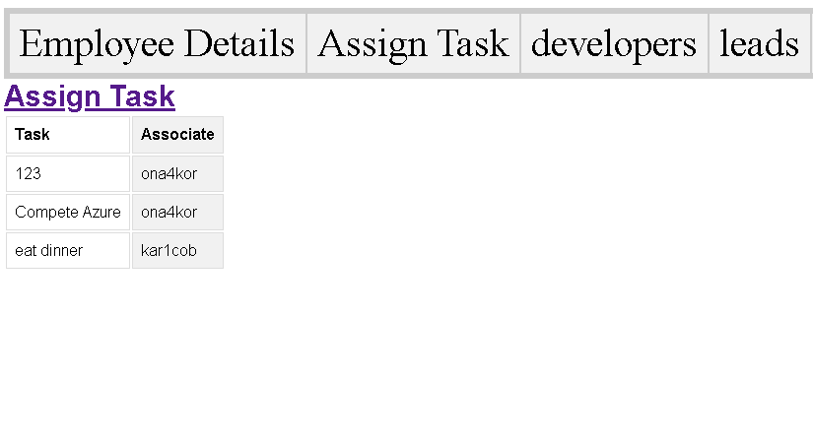

**Figure: -8- Assign task page**

On clicking the assigned task link, the manager will get the list of all the leads and developers t. The manager needs to select the employee and give the task description and click on assign task. It will get reflected in the respective employee login to whom the task is assigned. The manager can also able to see the list of all the tasks that were assigned by him/her.

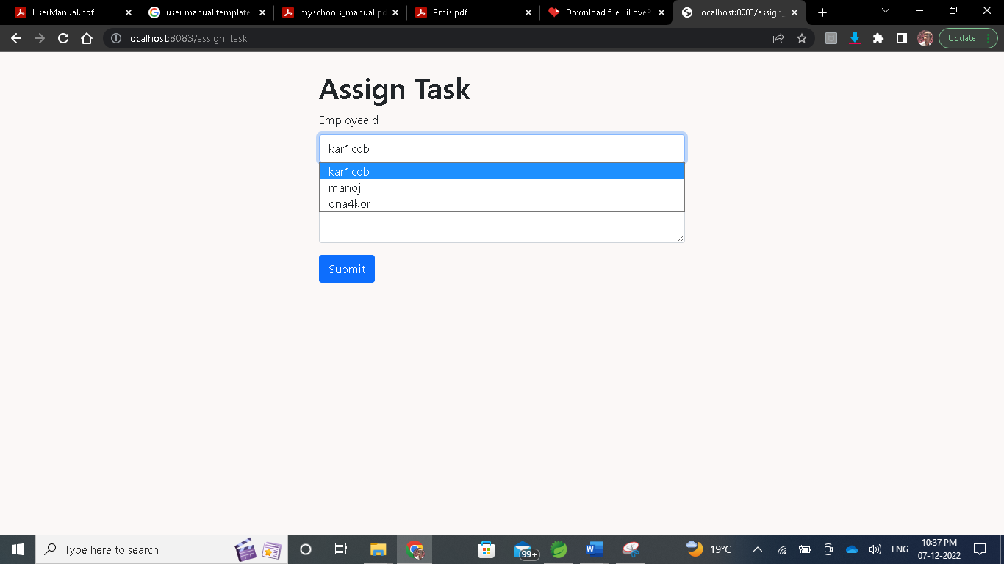 **Figure: -9- Select employee to whom the task has to be assigned**

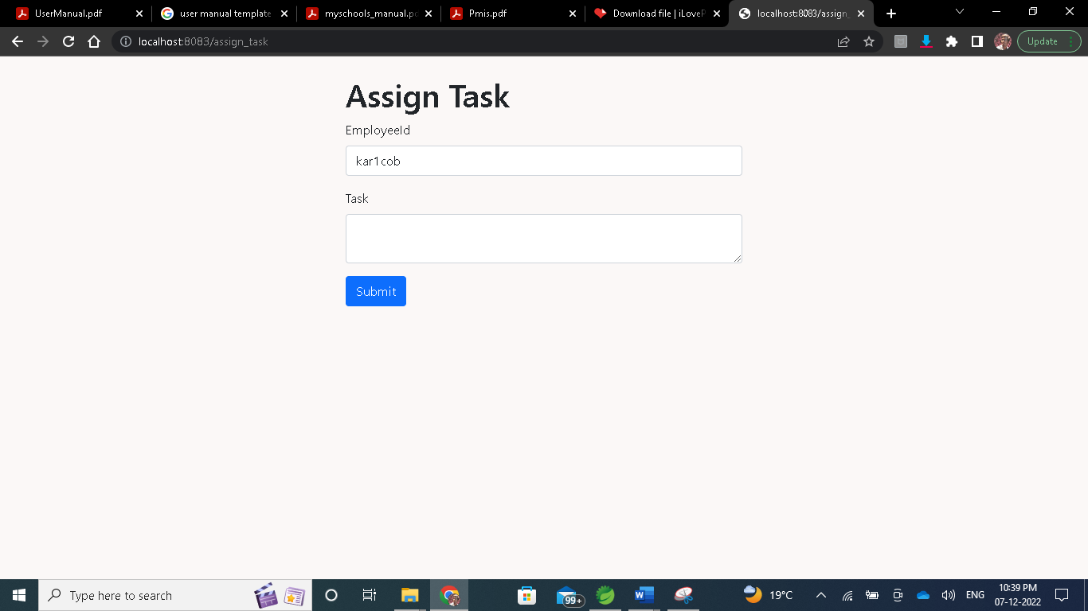

**Figure: -9- Enter the task description**

**APPENDIX**

Role details

Level-52 --------MANAGER

Level-51---------LEAD

Level-50---------DEVELOPER